Use case diagram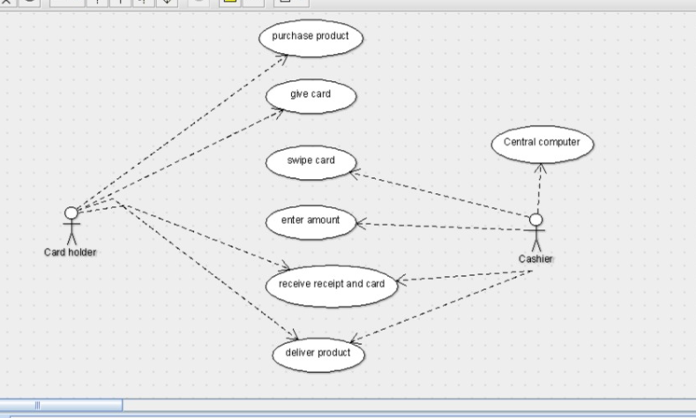

Class diagram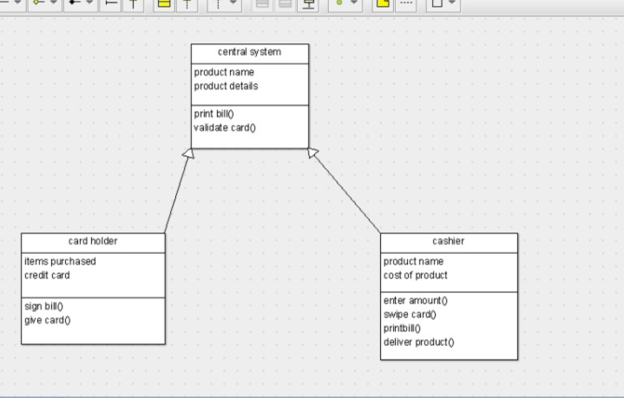

public class card holder extends central system {

public items purchased;

public credit card;

public void sign bill() {

}

public void give card() {

}

public class central system {

public product name;

public product details;

private void print bill() {

}

public void validate card() {

}

}public class cashier extends central system {

public product name;

public cost of product;

public void enter amount() {

}

private void swipe card() {

}

public void printbill() {

}

public void deliver product() {

}

}

SEQUENCE DIAGRAM

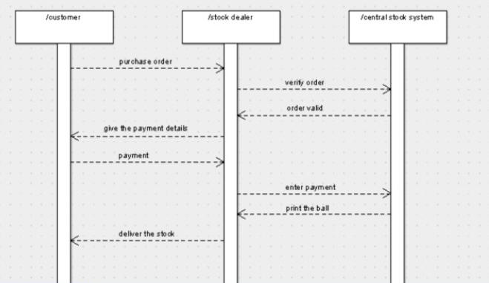

COLLABORATION DIAGRAM

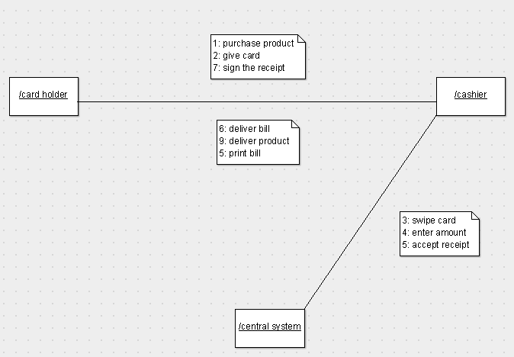

ACTIVITY DIAGRAM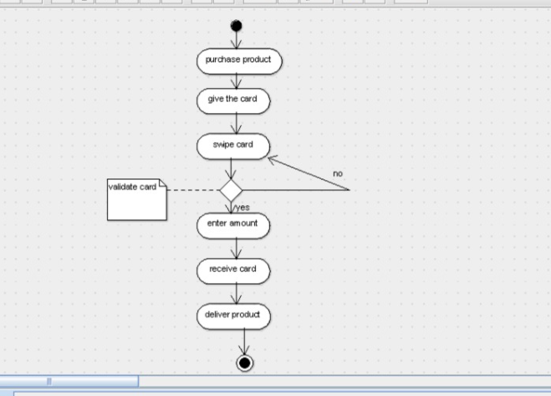

COLLABRATION DIAGRAM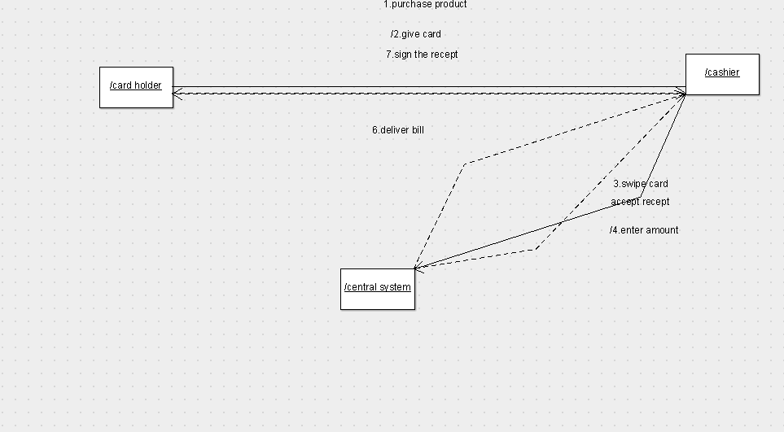

STATE CHART DIAGRAM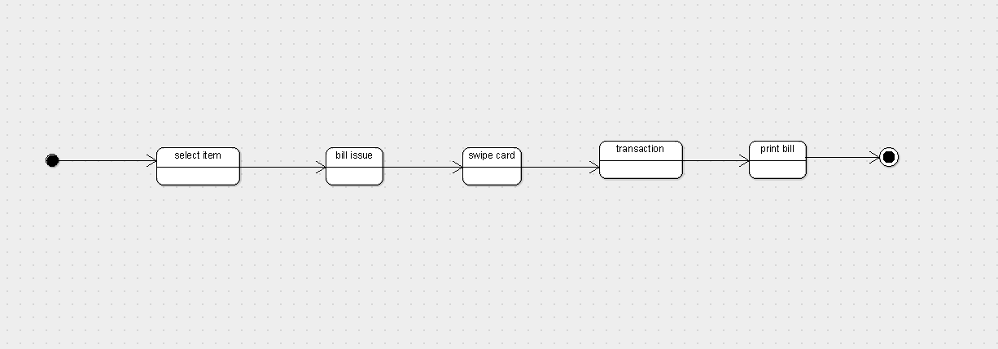

COMPONENT DIAGRAM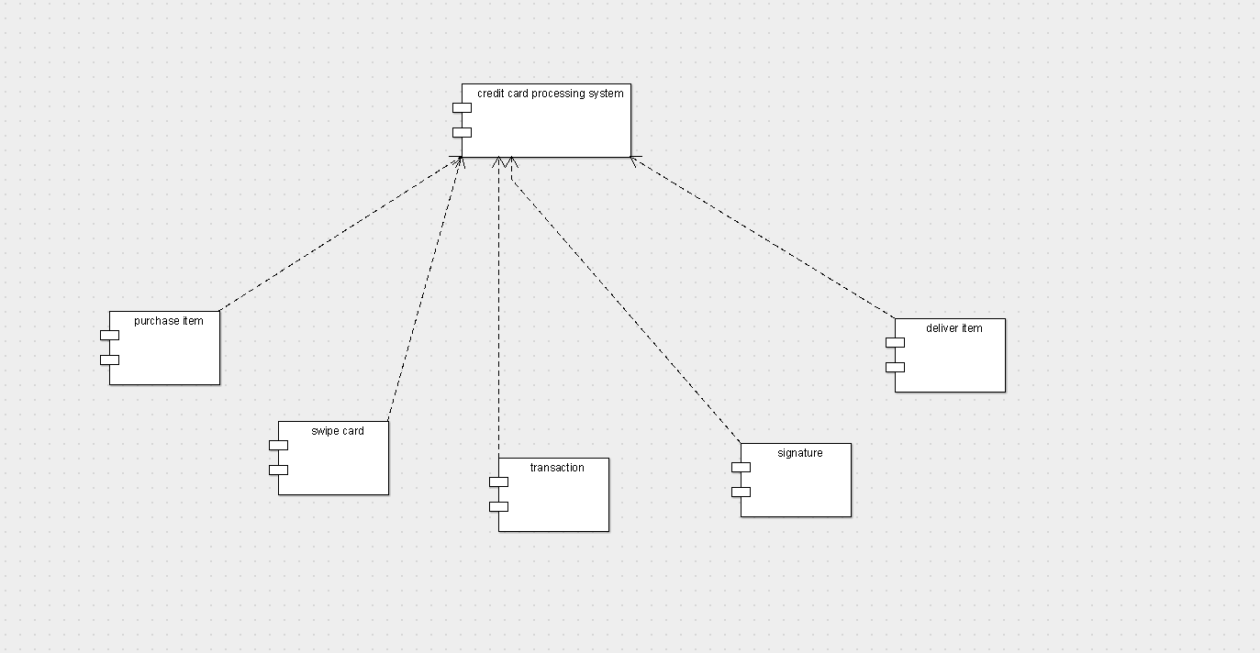

DEPLOYMENT DIAGRAM